CS Dept. student job hunting tracking system-Final

1. Team Member

Haorui Chen (4454226030), Zihao Zhang (4798698599), Zehao Li (3717211170)

1. Links:

code:

demo video:

1. Tech selection

Frontend: React.js; Backend: Node.js; Database: MySQL+Firebase

1. Design & Architecture Choices

The frontend is designed as a single page app(SPA), i.e. all functionalities are provided in a single page.

The backend can be basically divided into 4 parts: index.js serving as entrances for all requests from frontend; route.js route hdfs commands in task 1 to corresponding functions; cmd.js is for implementing all commands; analysis.js is for handling search & analysis functions in task 2.

Regarding multi-database issue, our design is to insert/update data to both DBs so that we don’t need to consider synchroization at all. Only when we want to read data, e.g. ls/cat command in task 1 & search/analysis in task 2, we can choose the source DB we want to read from, and it’s also a way to check the data consistency between 2 DBs.

1. DB Conceptual design

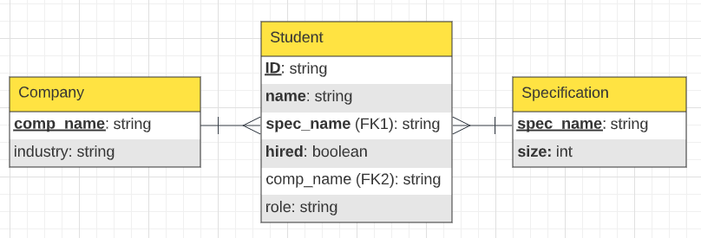

This DB model is succinct in tracking recording student job hunting status while avoiding gathering redundant information/violating students’ privacy.

1. Web App
2. DB selection



Simply a group of mutex buttons placed at the top of the page. The selected button indicates current DB you are reading from. As mentioned in the previous part, this is only useful with ls/cat command and seatch & analysis functionalities.

1. file system navigation

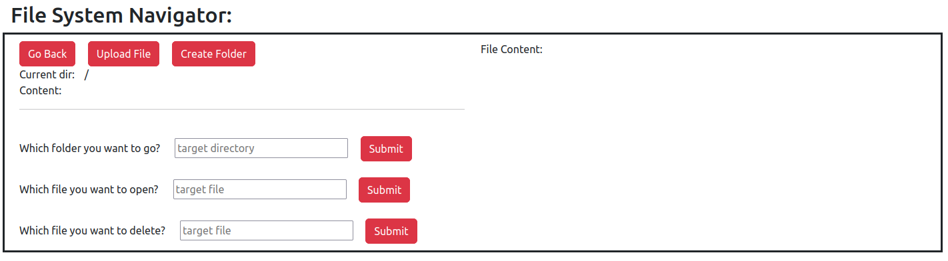

1. Go Back

The button implements ‘cd’ command with parameter being ‘..’, indicating the parent directory. Upon clicking, The content of iii) & iv) will be updated to be the path of parent directory and list of folders and files in it.

Although when we do ‘cd ..’ in the root directory we will not go elsewhere, this may appear counter intuitive to general users (we should be able to go back further when being at root dir after all), so this button will be hidden when current directory is ‘/’.

1. Upload File

The button implements ‘put’ command.

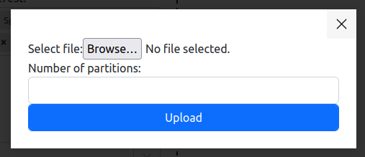

Upon clicking, a popup window will appear, enabling user to select file and partitions. When user click ‘Upload’ with no file selected, an alert will popup:

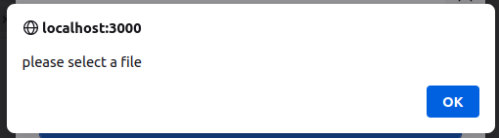

And when no desired paartition number is specified, the user get the alert below:

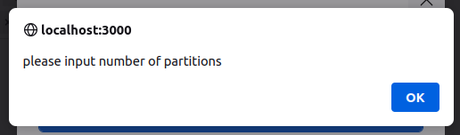

Such alert will also appear when user try to submit without anything in the input box for Create Folder, go to child directory, show file content and remove file. No screenshot will be given for brevity.

When such popup window appears, the rest of the page will get darkened to get users’ focus on the popup. Click the dark area or the ‘close’ button will both enable us to exit the popup without submitting the form. This also applies to the pop for ‘Create Folder’ button.

After submitting the file and partition number, an ‘ls’ command will then be sent to the backend as content of current folder has just been updated.

1. Create Folder

This button implements ‘mkdir’ command. The popup window looks like below:

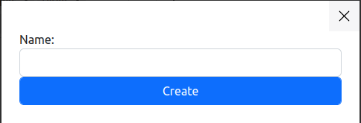

After submitting the name of the new folder, an ‘ls’ command will then be sent to the backend as content of current folder has just been updated.

1. Current dir

This shows the current folder the user is in. When first entering the system, the user will be placed at root dir ‘/’ by default.

1. Content

This shows the result of ‘ls’ command. Note that ‘ls’ command does not have a dedicated button to trigger, it will be executed on every update of current folder indicated in iii) ‘Current dir’ instead.

1. ‘Which folder do you want to go?’

This implements ‘cd’ command with parameter being one of the child directories (if any) of current one, listed in iv). Upon submitting, The content of iii) & iv) will be updated to be the path of target directory and list of folders and files in it.

1. ‘Which file do you want to open?’

This implements ‘cat’ command with parameter being one of the files (if any) of current directory, listed in iv). We can see that the right half of the window shows ‘File Content:’, the following content will be content of the target file here.

1. ‘Which file do you want to delete?’

This implements ‘rm command’ with parameter being one of the files (if any) of current directory, listed in iv). Upon submitting, The content of iv) will be updated to be the path of target directory and list of folders and files in it.

1. Search & Analysis

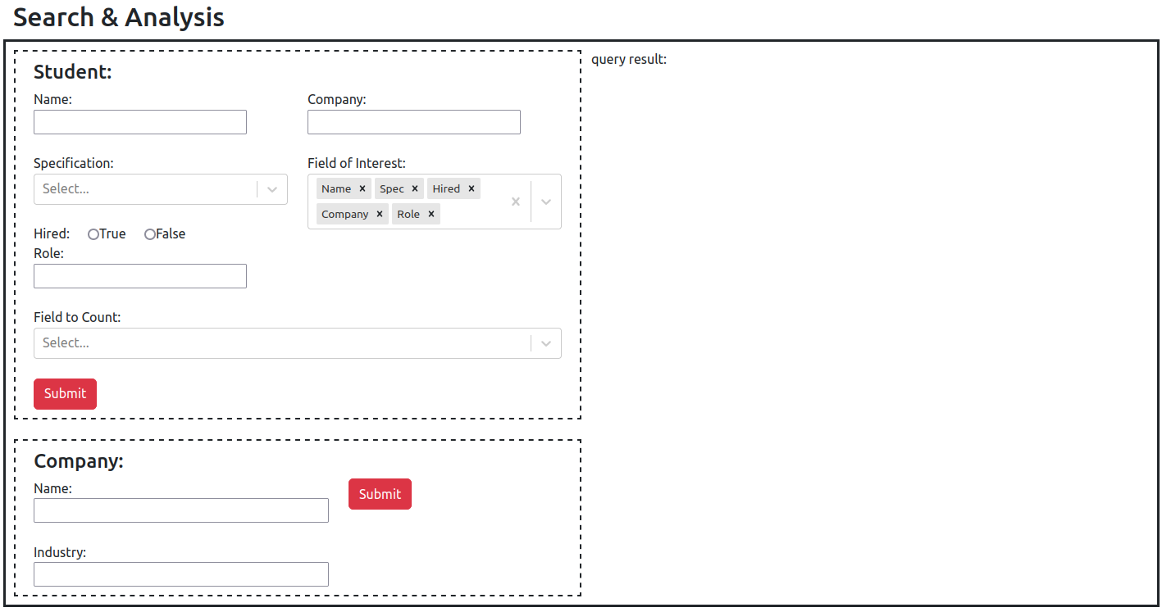

We provide search and analysis functionalities on 2 entities: Student and Company.

For Student entity, we support search based on any of its attribute or their combinations. ‘Field of INterest’ indicates the field to project in final result, resembling columns to ‘SELECT’ in SQL; ‘Field to Count’ is for analysis functionality,

For Company entity, we support search based on any of its attribute or their combinations.

Query result will be shown in the ‘query result:’ part on the right half, indicating input and output for each step of MapReduce.

1. MySQL implementation

We used MySQL to emulate the storage process of HDFS and do Map-Reduce searching and analyzing based on Node.js. We have namenode(named “meta” in MySQL) table to record the fundamental information of both the folders and files, such as file(folder) name, inumber, creation time and file type. And, we have partition table(named Table ‘Part’ in MySQL) to trace all the partitions that are used to record the addresses where we save each partition of the real data. Besides, there are datanodes created and stored in MySQL, and each represents a partition of corresponding file. When inputting files, the meta table records the basic information of the file. Then, a certain number of partition numbers would be generated. For each partition number, we create a table for it. After that, we hash one of the attributes for each row of the data and store them separately in different tables. When doing searching and analysis, we firstly look into the meta table and partition table to get all the partitions(tables) numbers involved this operation. Then we go into each table, filtering the valid rows and turn them into a new map. And then, to get the final result, we keep merging the list until there’s one list left.

1. Firebase implementation
2. Learning experience

Haorui Chen:

I am in charge of the whole frontend and architecting the whole project. Being one of the first 2 projects that I apply React.js since first learned it this summer, I greatly familiarized with this library through building this Web App. I got much more familiar with advanced topics like passing Components as props and useEffect and useState hook. This is also the first time I try with CSS and styling a webpage. Such frontend experience also helped me in my concurrent internship at CSSE Lab.

This is also the first time I try to architect a full-stack project from a top-down way. I paved the connection between frontend and backend endpoints and tested connection with MySQL and Firebase in JavaScript, thus enabling me to become more familiar with Node.js framework and full-stack architecture.

Zihao Zhang:

My job is to develop the MySQL emulation of HDFS and Map-Reduce using Node.js and JavaScript in this project. I think it’s a precious opportunity for me to apply what we learned in class theocratically to real application and development. My teammates and I showed great passion and responsibilities in this wonderful journey. We are so glad to see finally we implemented this application from just some simple concepts. Besides, I have learned much knowledge in Node.js backend development. This was the first time I develop an app in Node.js. The main feature of it is its nonblocking synchronization, which takes me a lot of effort to get used to. As my knowledge of synchronized application development grew, I got to implement some relatively complicated algorithms with it like building hierarchical file system with parent-child relations. So proud that I finally made it. What a journey!